Grilled Napoli Pizza

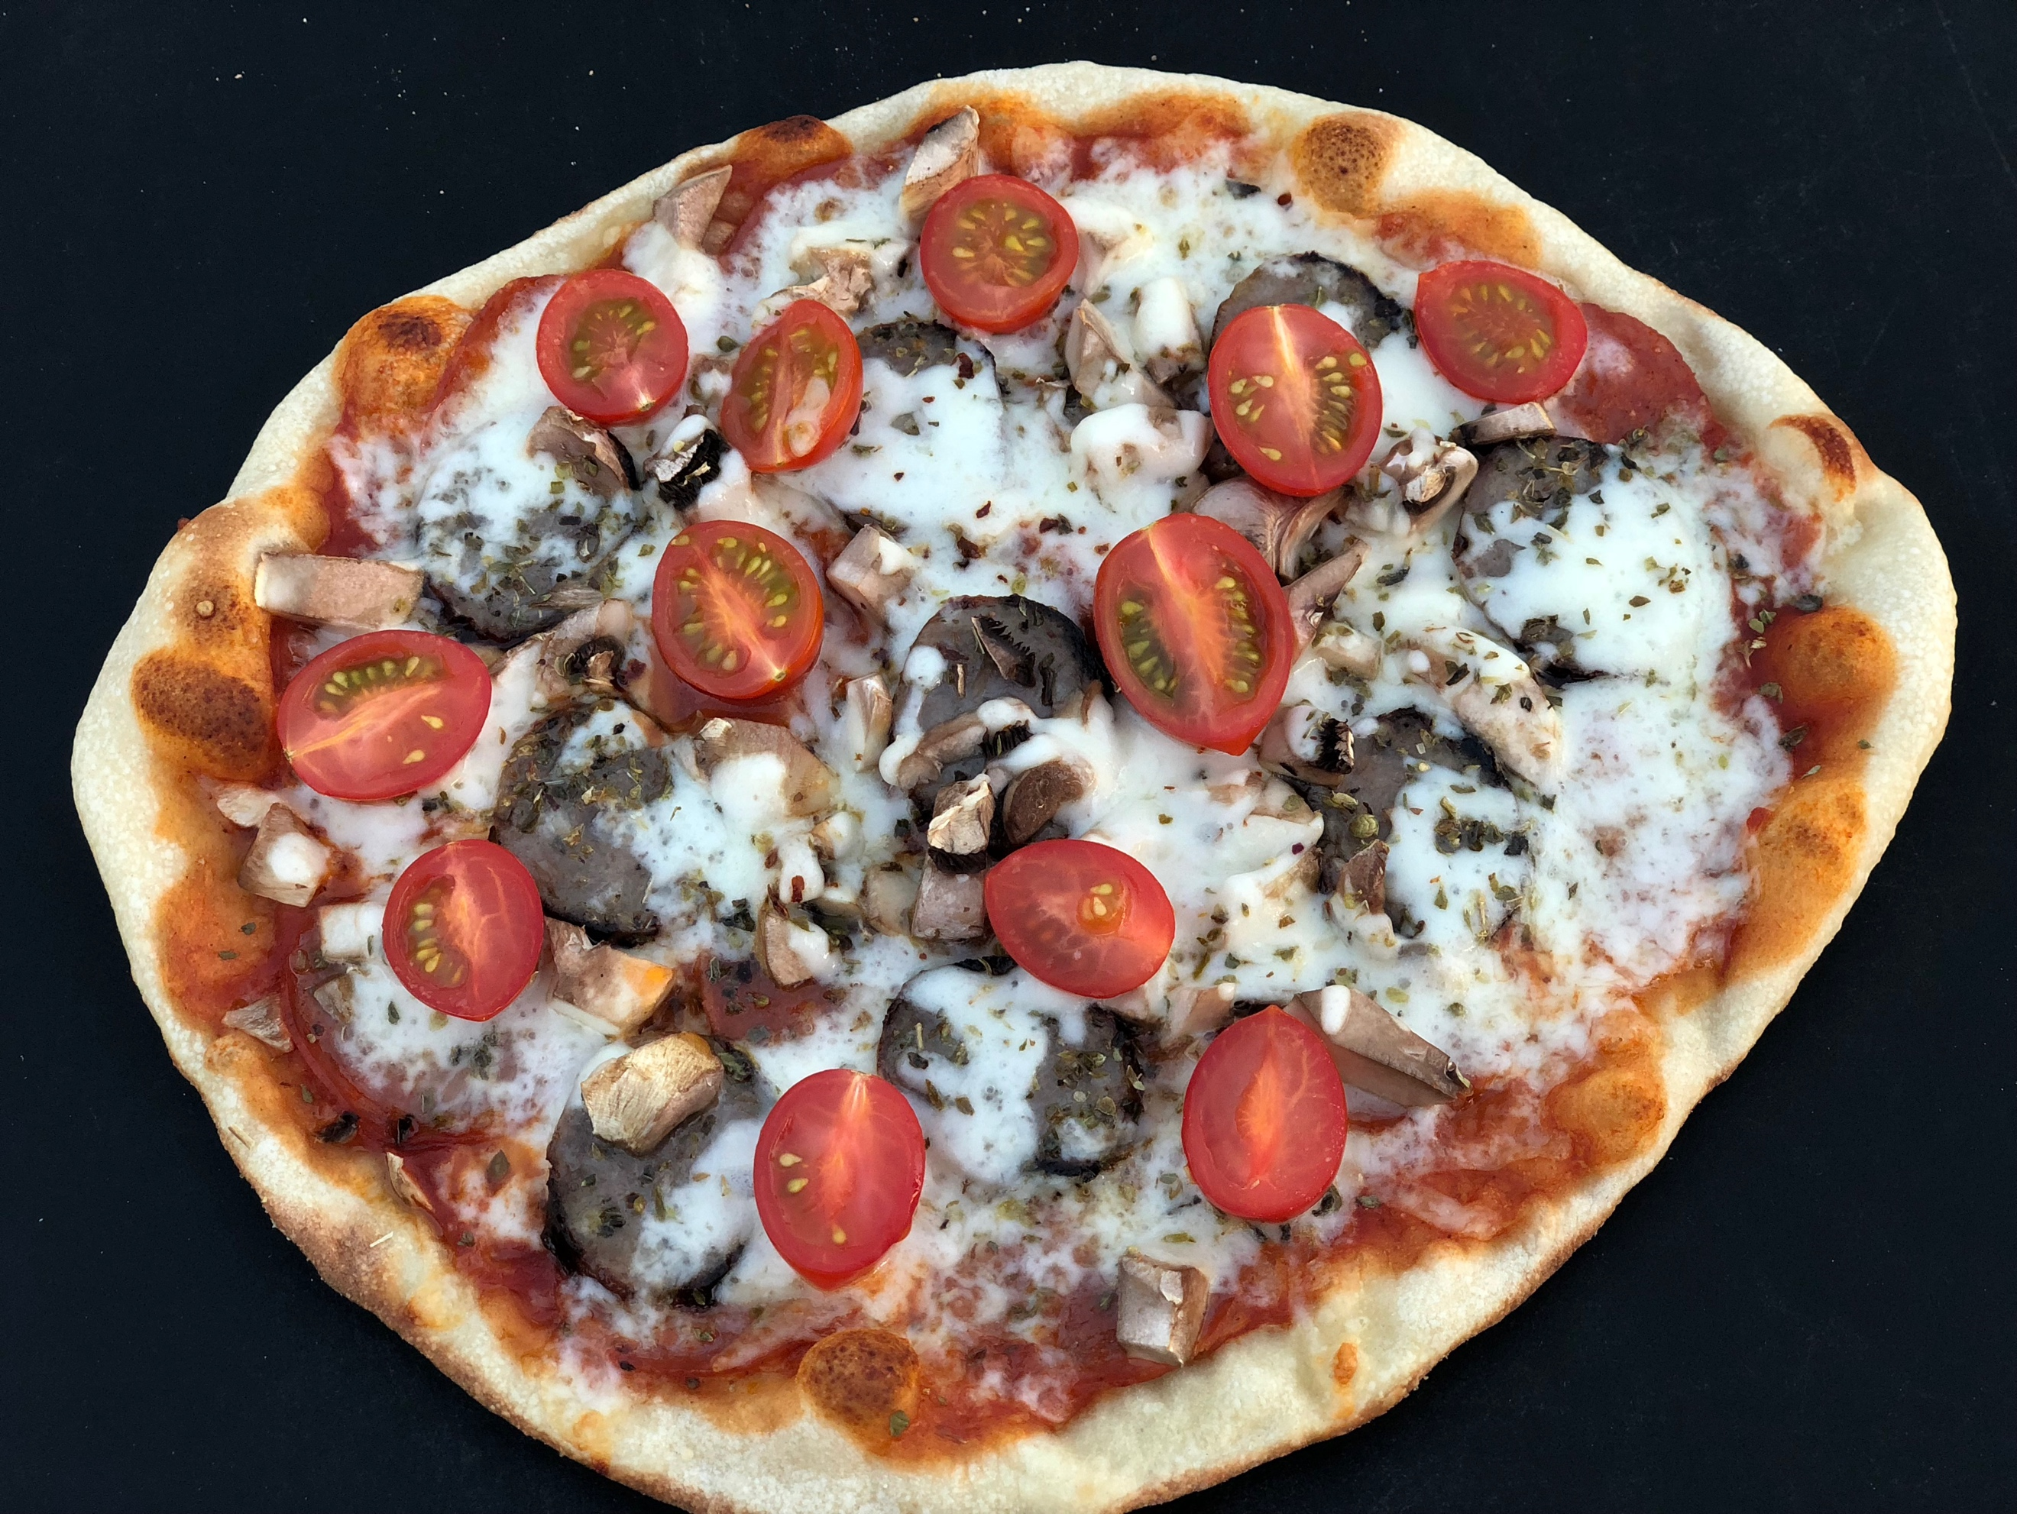

On a trip to Naples, Italy, about ten years ago, my husband and I discovered the best pizza we had ever tasted. Seriously! And obviously memorable if I’m blogging about this now. The crust was super thin, light and crispy and topped with most delicious red sauce and cheese. This set the bar for us…in search of authentic Napoli pizza at home.

New York pies can come close, but we live on the West Coast…and not much compares. We wanted to recreate this pizza at home without having to buy another major appliance like a pizza oven. So, we turned to our favorite appliance…the outdoor grill.

Although it’s possible to grill pizza directly on the grates, we use an Emile Henry Grilling Stone to quickly grill our pizza and create a crispy crust. The heat from the grill will cook all of your favorite toppings. And the best part? Your pizza is ready in less than five minutes!

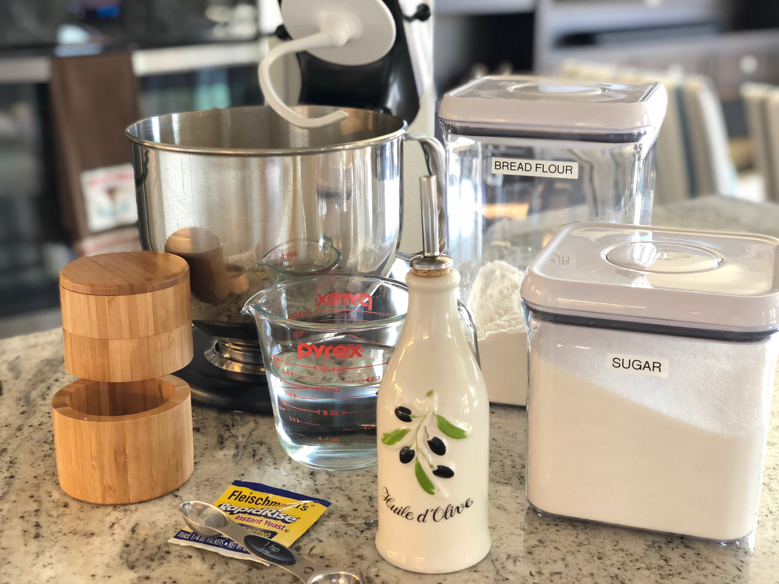

The thing about pizza is it’s all about the ingredients. From the freshest topping to the best pizza dough. In a pinch, we will buy store bought dough, but this recipe is the best I’ve ever tasted. And it’s quick and simple, too.
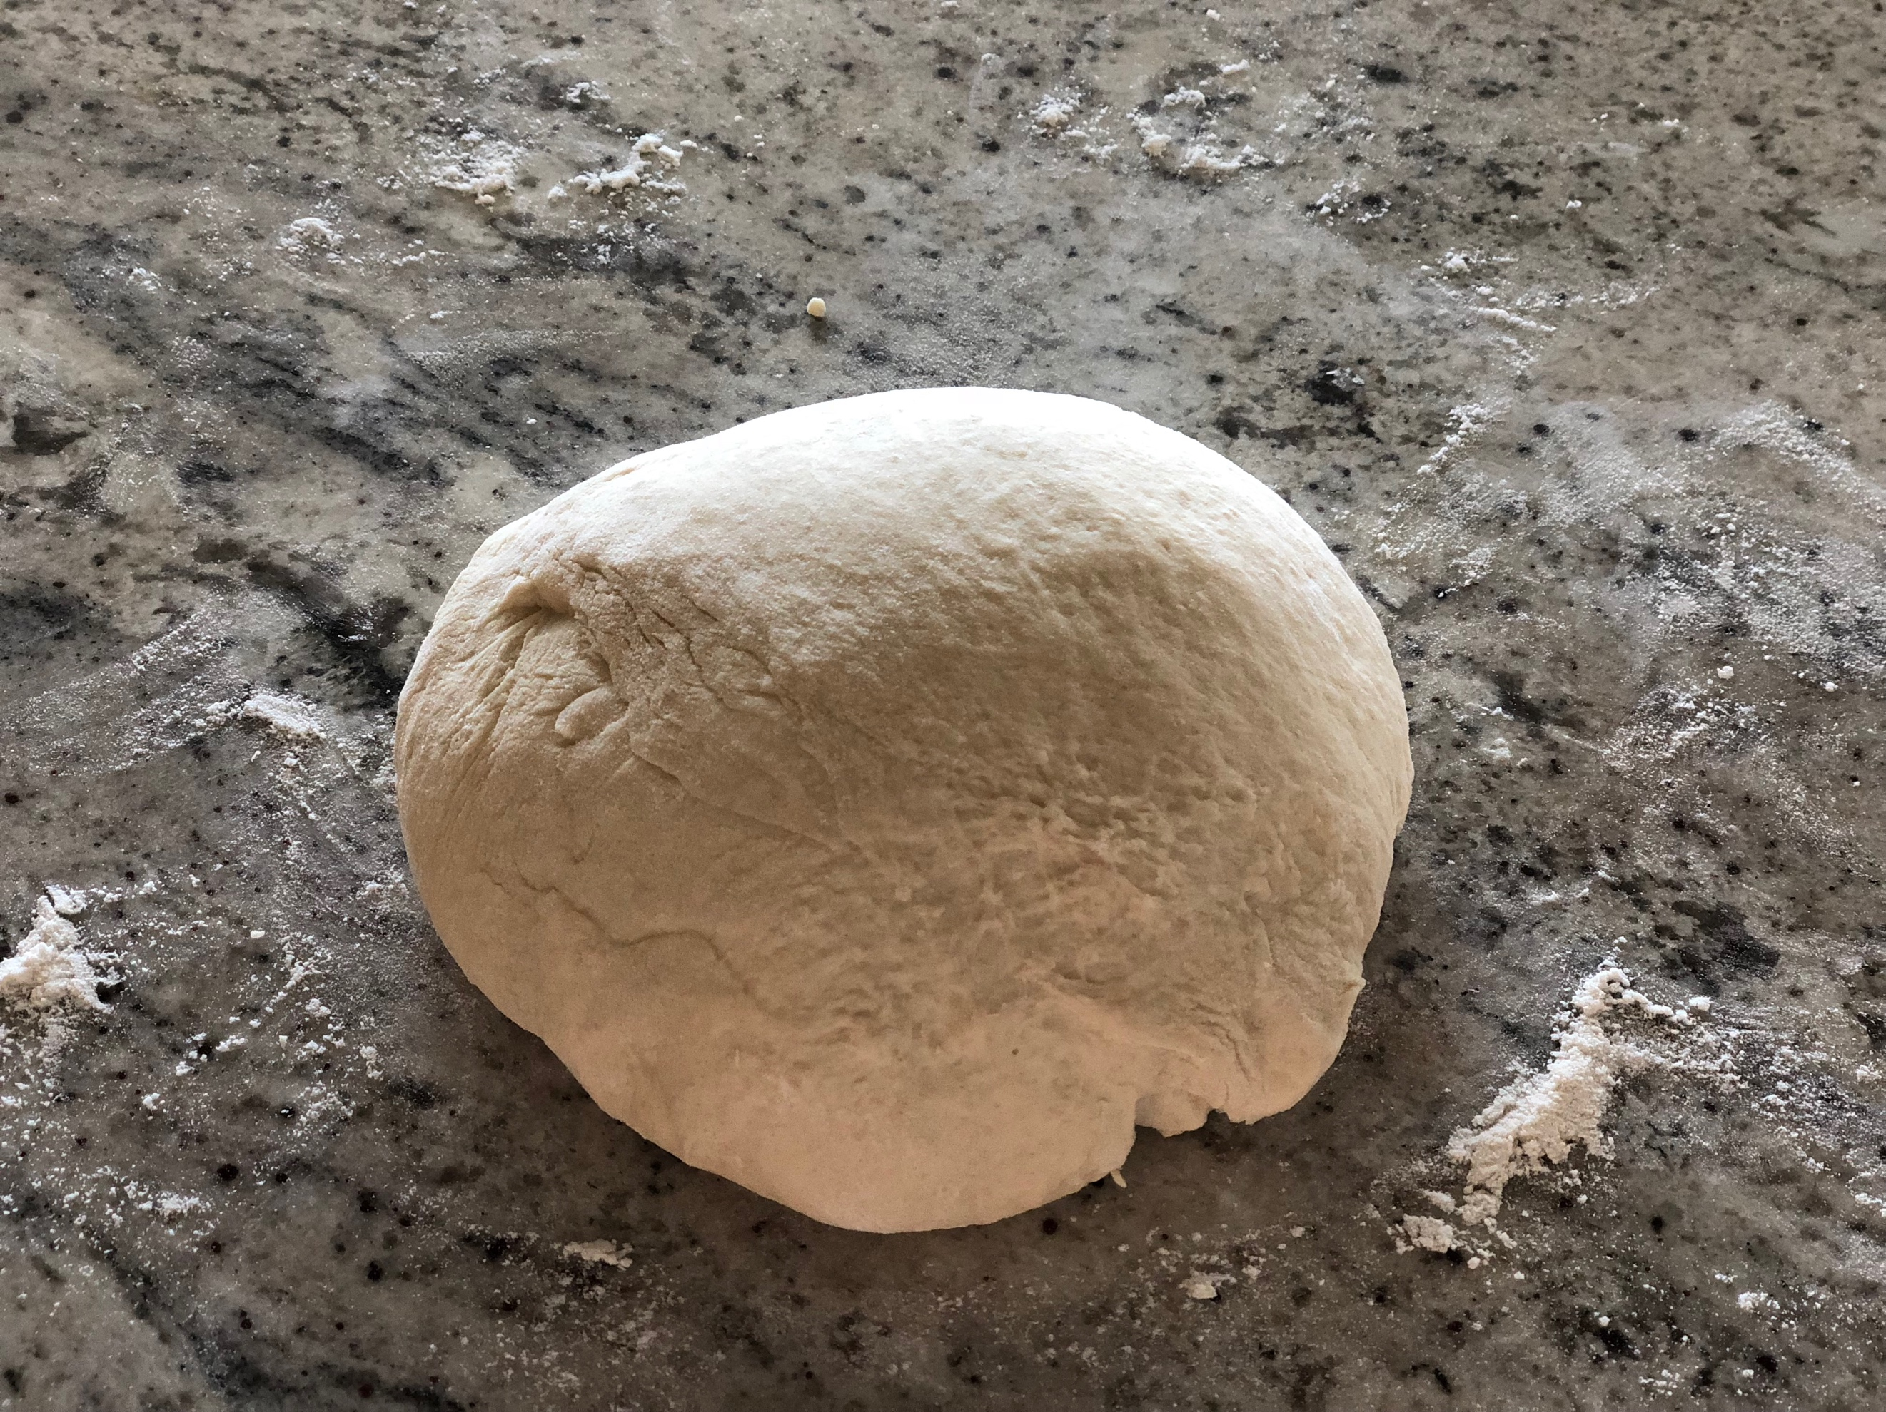

The pizza dough uses bread flour to give it a great crispy crust. Combine the ingredients in stand mixer until it comes together in a solid ball. If the dough is too wet, add a little flour, 1 tablespoon at a time. If the dough is too dry, add a little water, 1 tablespoon at a time. Turn out onto a floured surface and lightly kneed into a ball. Transfer to an oiled bowl, cover with plastic wrap, and set it in a warm place to double in size. I find my oven is the best place for this…but make sure your oven is OFF!

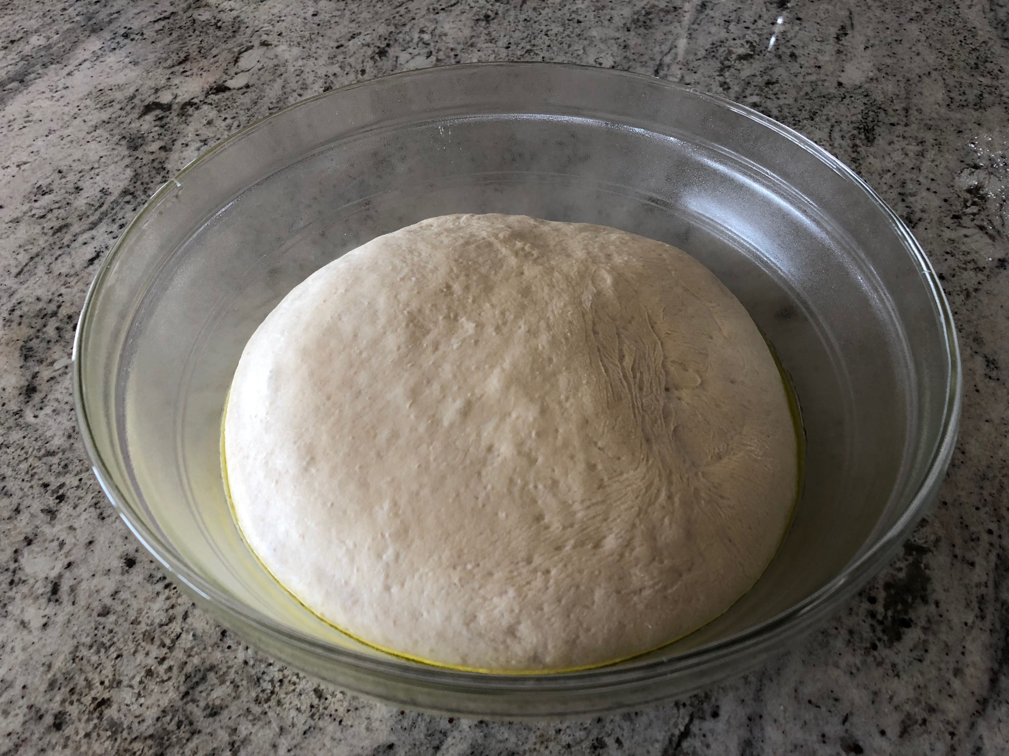

After about an hour, turn the dough out onto a floured surface and divide into 4 equal pieces. Cover with plastic wrap and let rest for 15 minutes. Then roll out with a rolling pin to about a 10-12 inch pizza crust on a floured surface.

If you start rolling your dough from a nice round ball, it’s much easier to create a round pizza. Personally, my pizza crust is a bit rustic (meaning I don’t work too hard at perfectly round!)

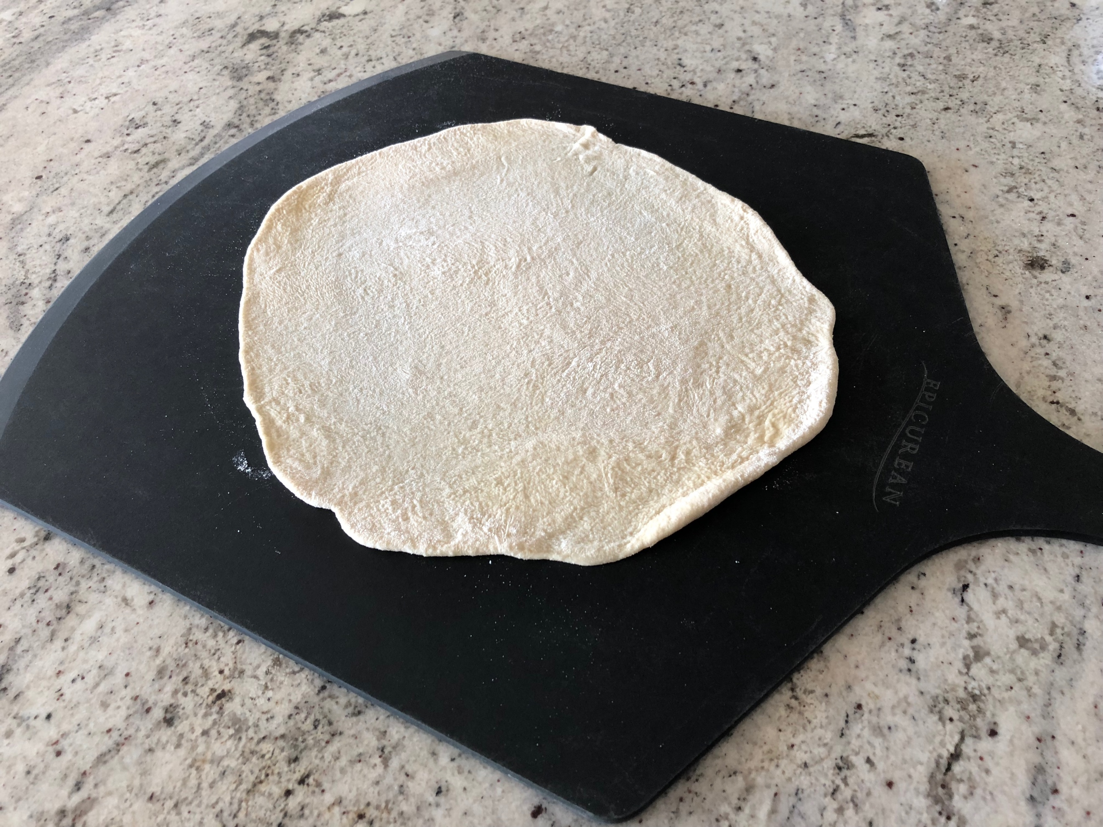

You can roll your dough out ahead of time, stack it between parchment paper, and place it in the fridge for a few hours until ready to use. This works really well if you’re having a pizza party – which we often do! Just take the dough out 30 minutes ahead of time to come to room temp.

Place the grilling stone on the grates and heat your grill on high for 20 minutes to get the stone nice and hot. We heat all burners and keep the lid closed.

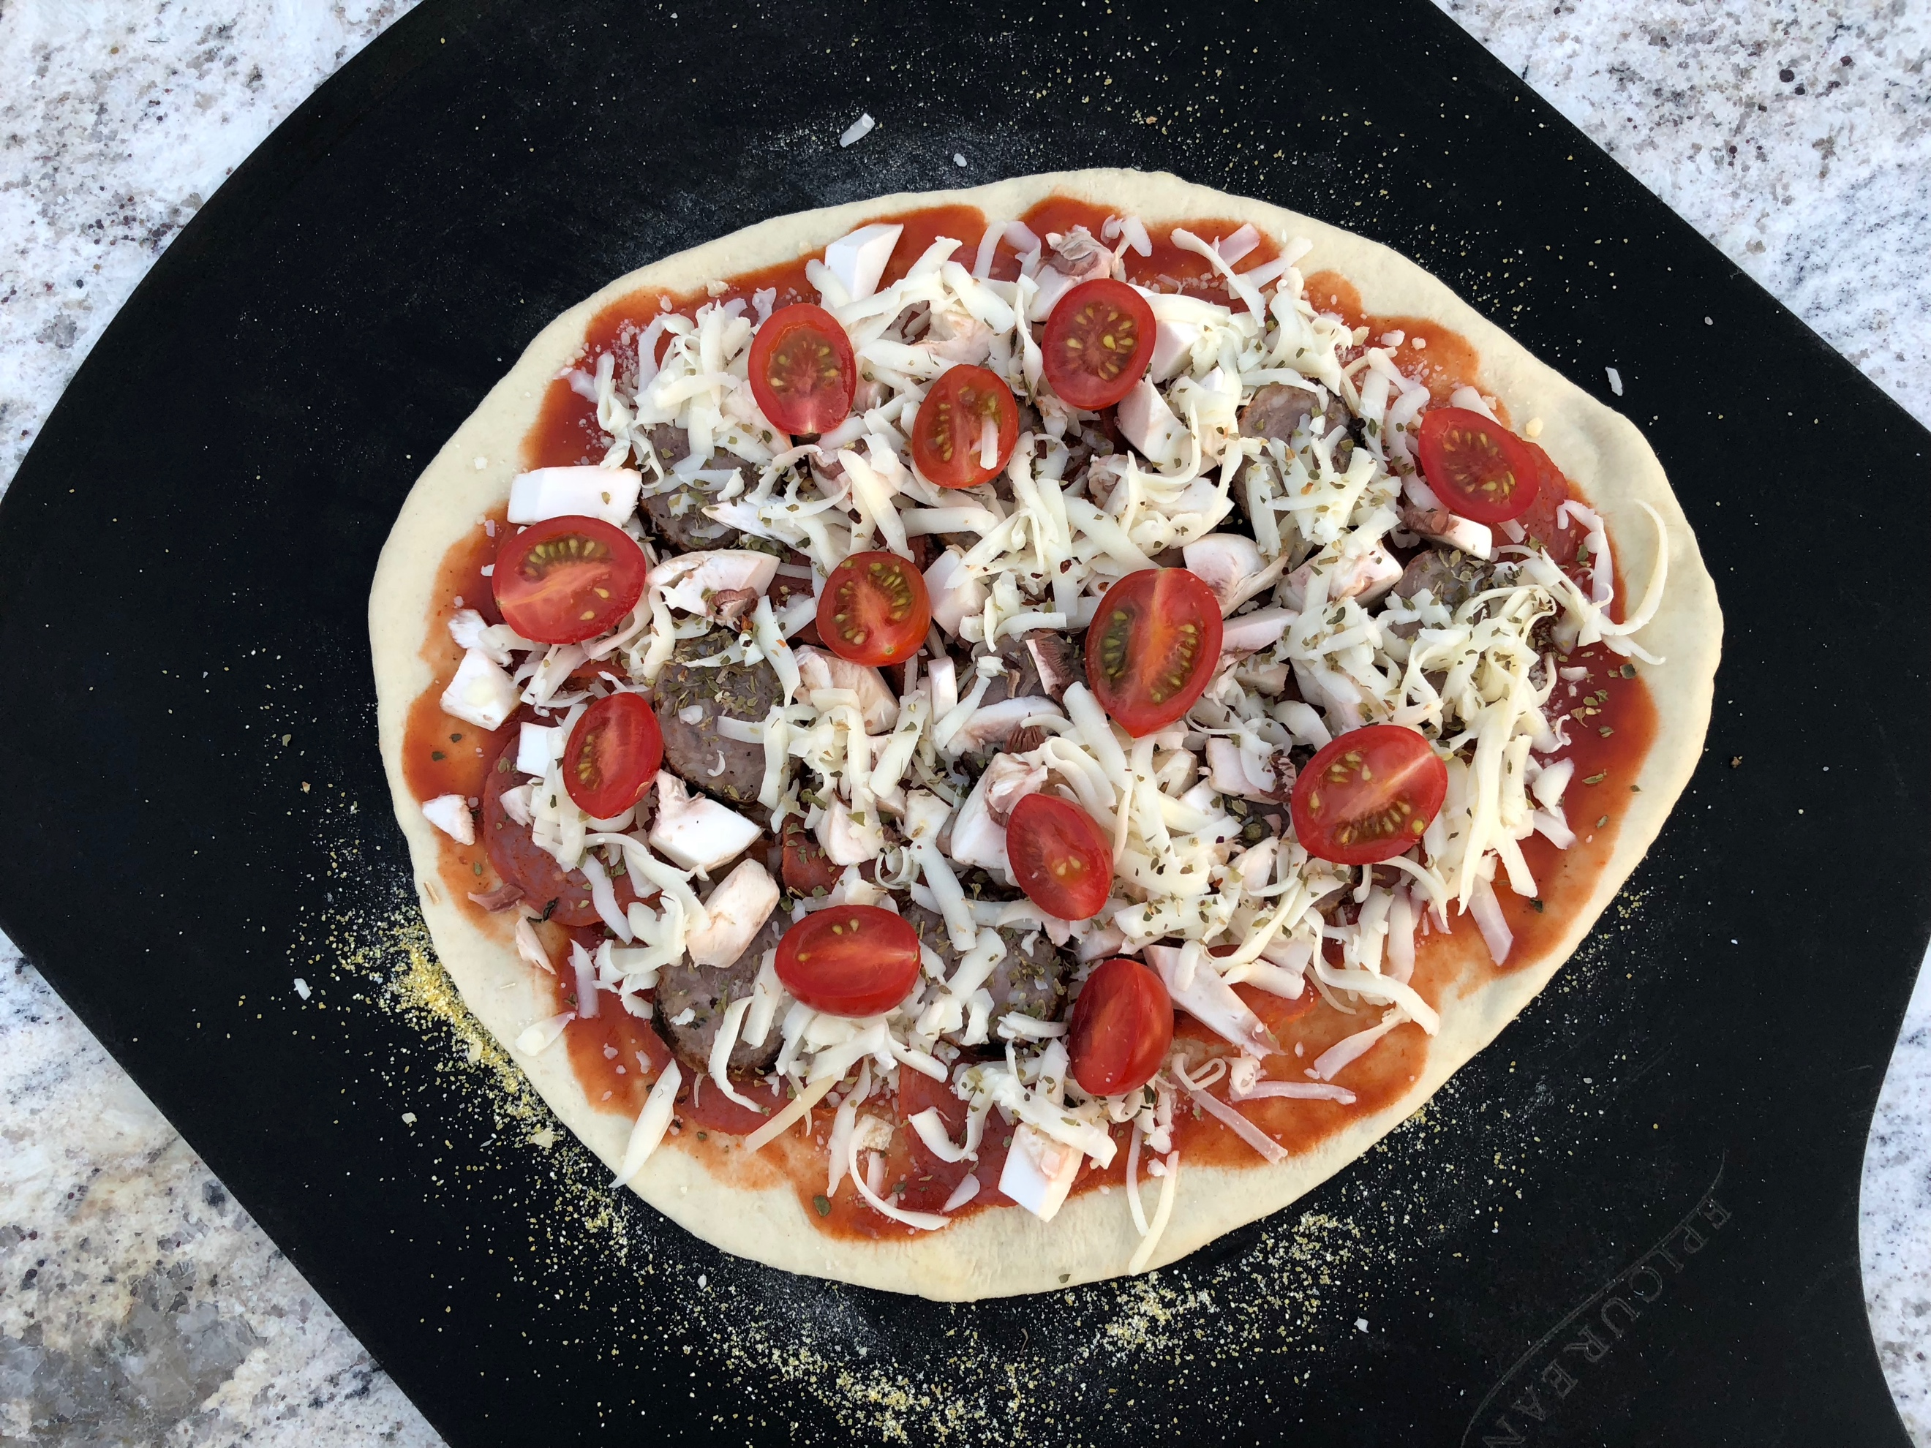

When the grill is ready, make a pizza! Using 1 tbs of corn meal, spread it out on a pizza peel and place the dough on top. This will help to slide the pizza onto the grilling stone. We have a few pizza peels in our house so that everyone can create their own pizza. Top with your favorite pizza topping – but not too much! Heavy toppings will make it difficult to slide onto the grilling stone.
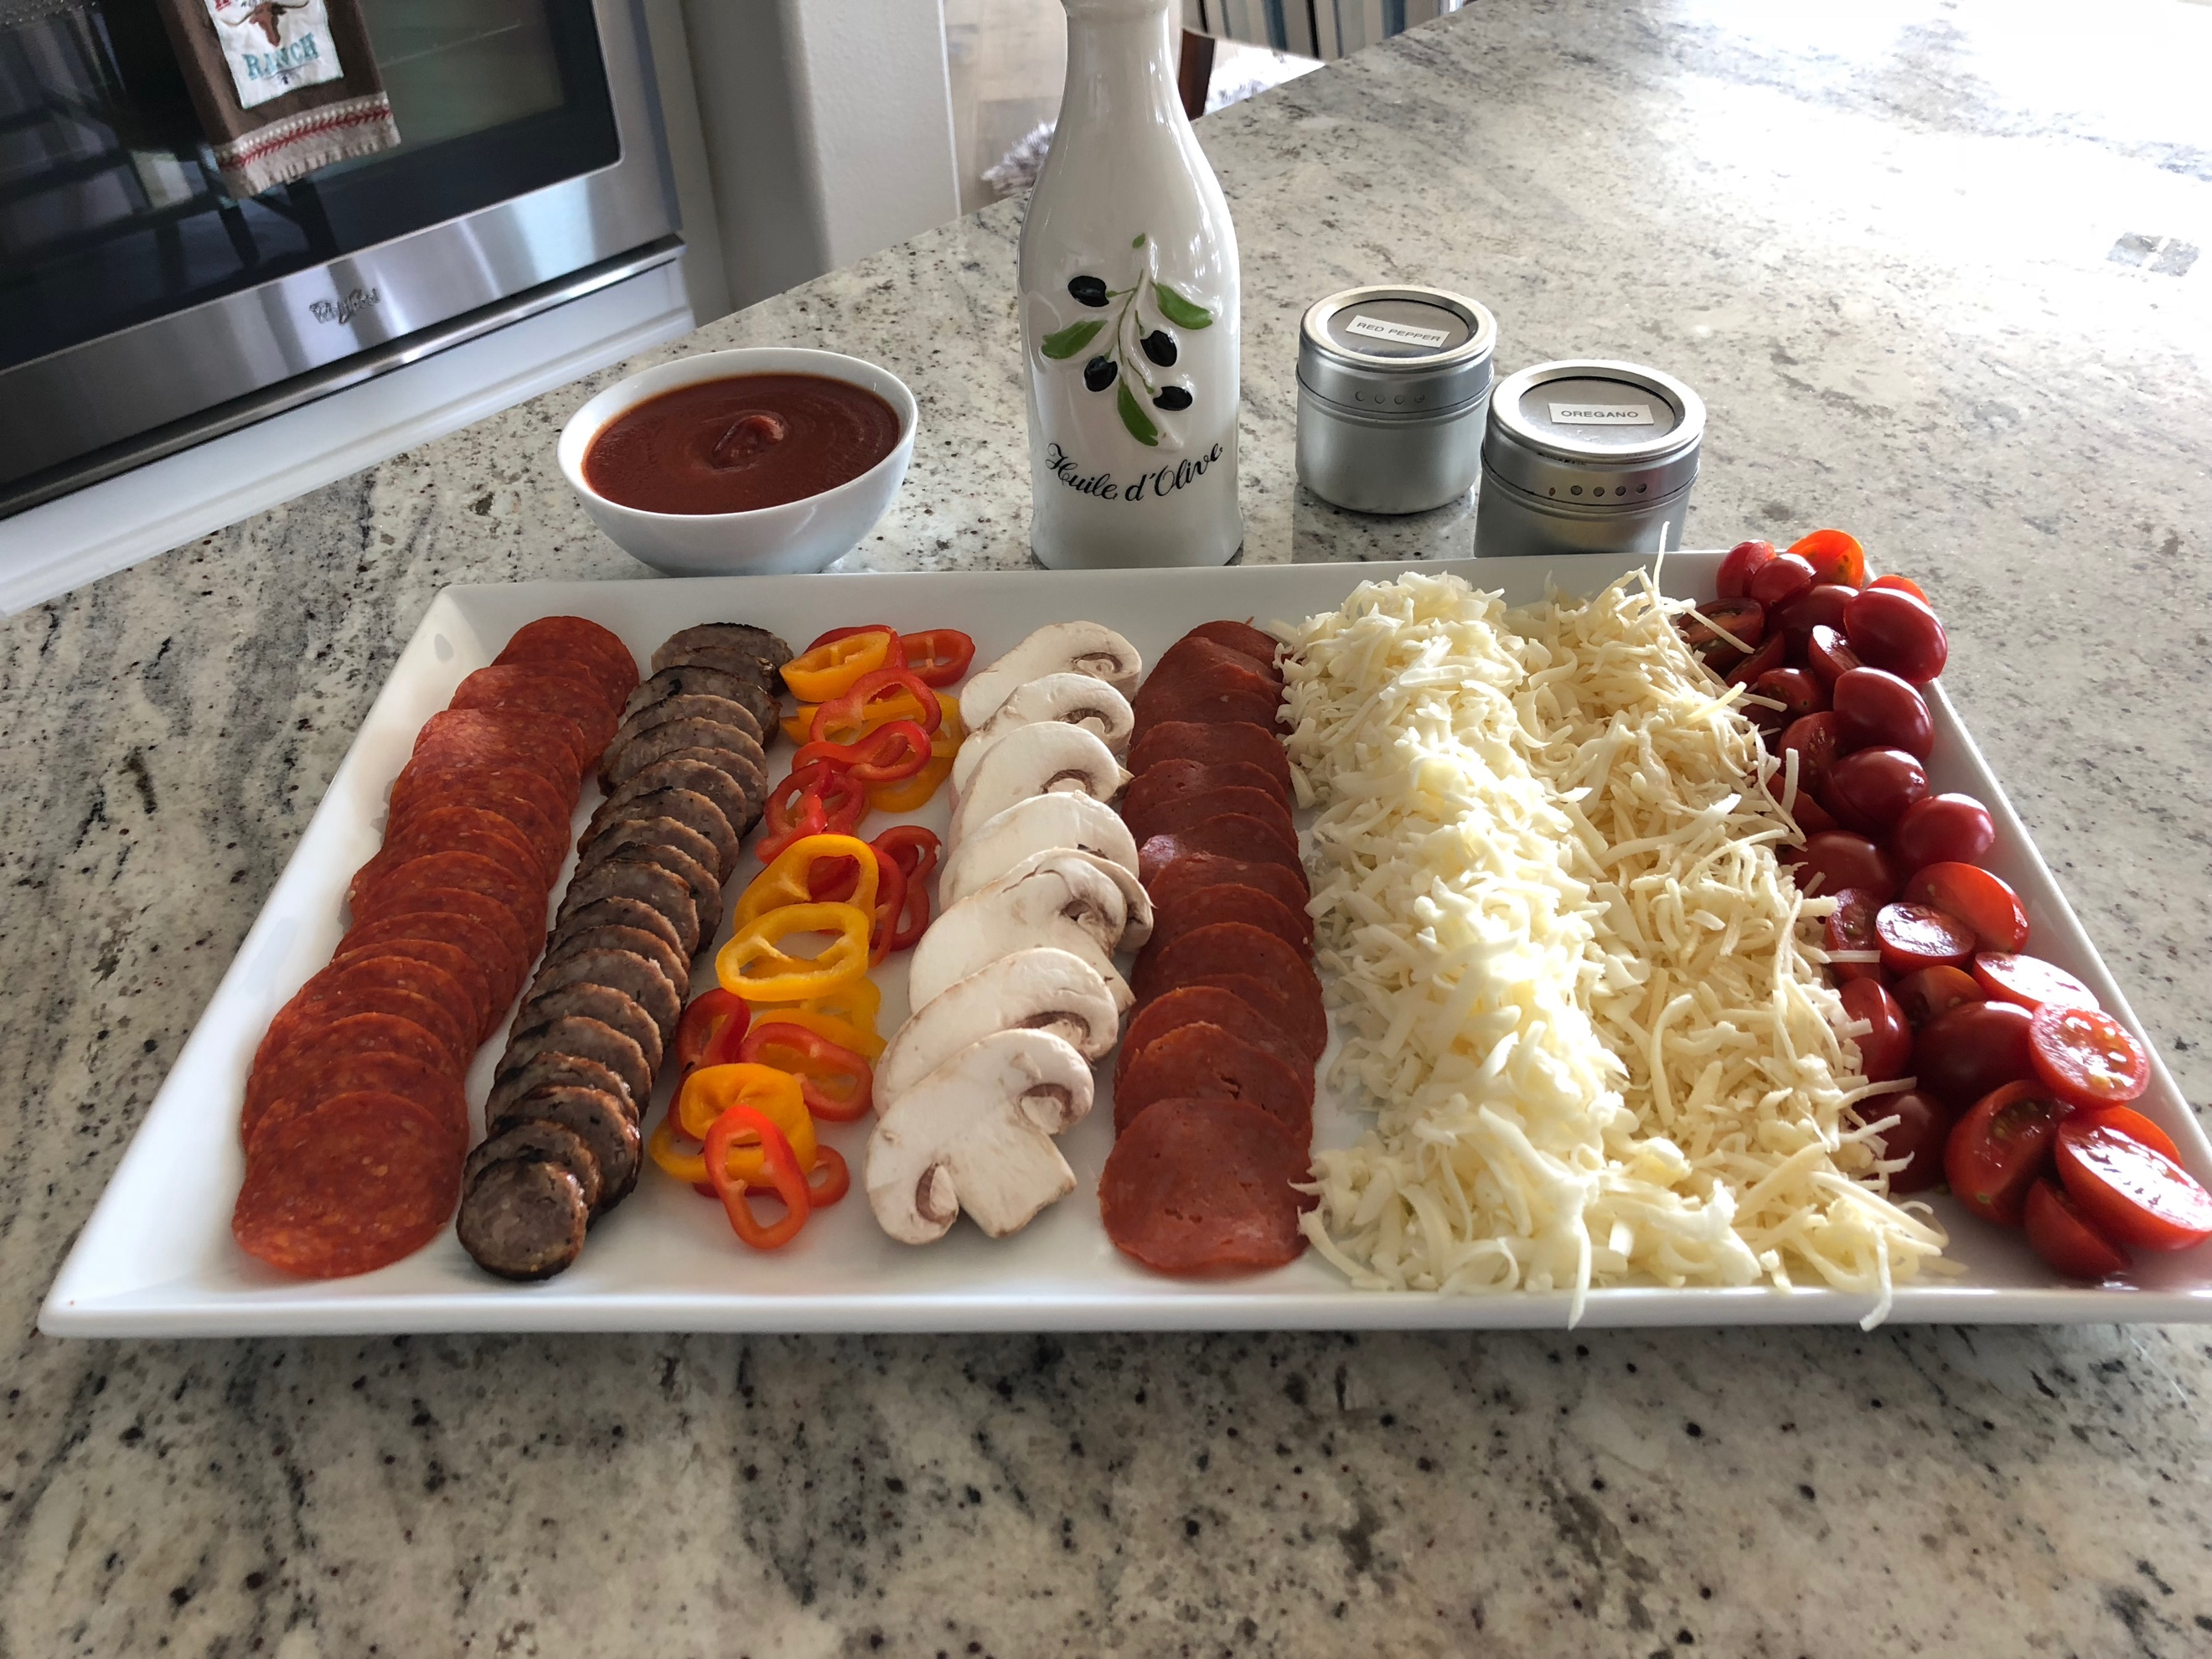

I have a secret tool to gently assist with sliding the pizza on/off the grill stone…a cake lifter! I use a Wilton 8” cake lifter. It’s small enough to help maneuver the dough off the pizza peel. Grill pizza for 3-5 minutes until the toppings are bubbling.

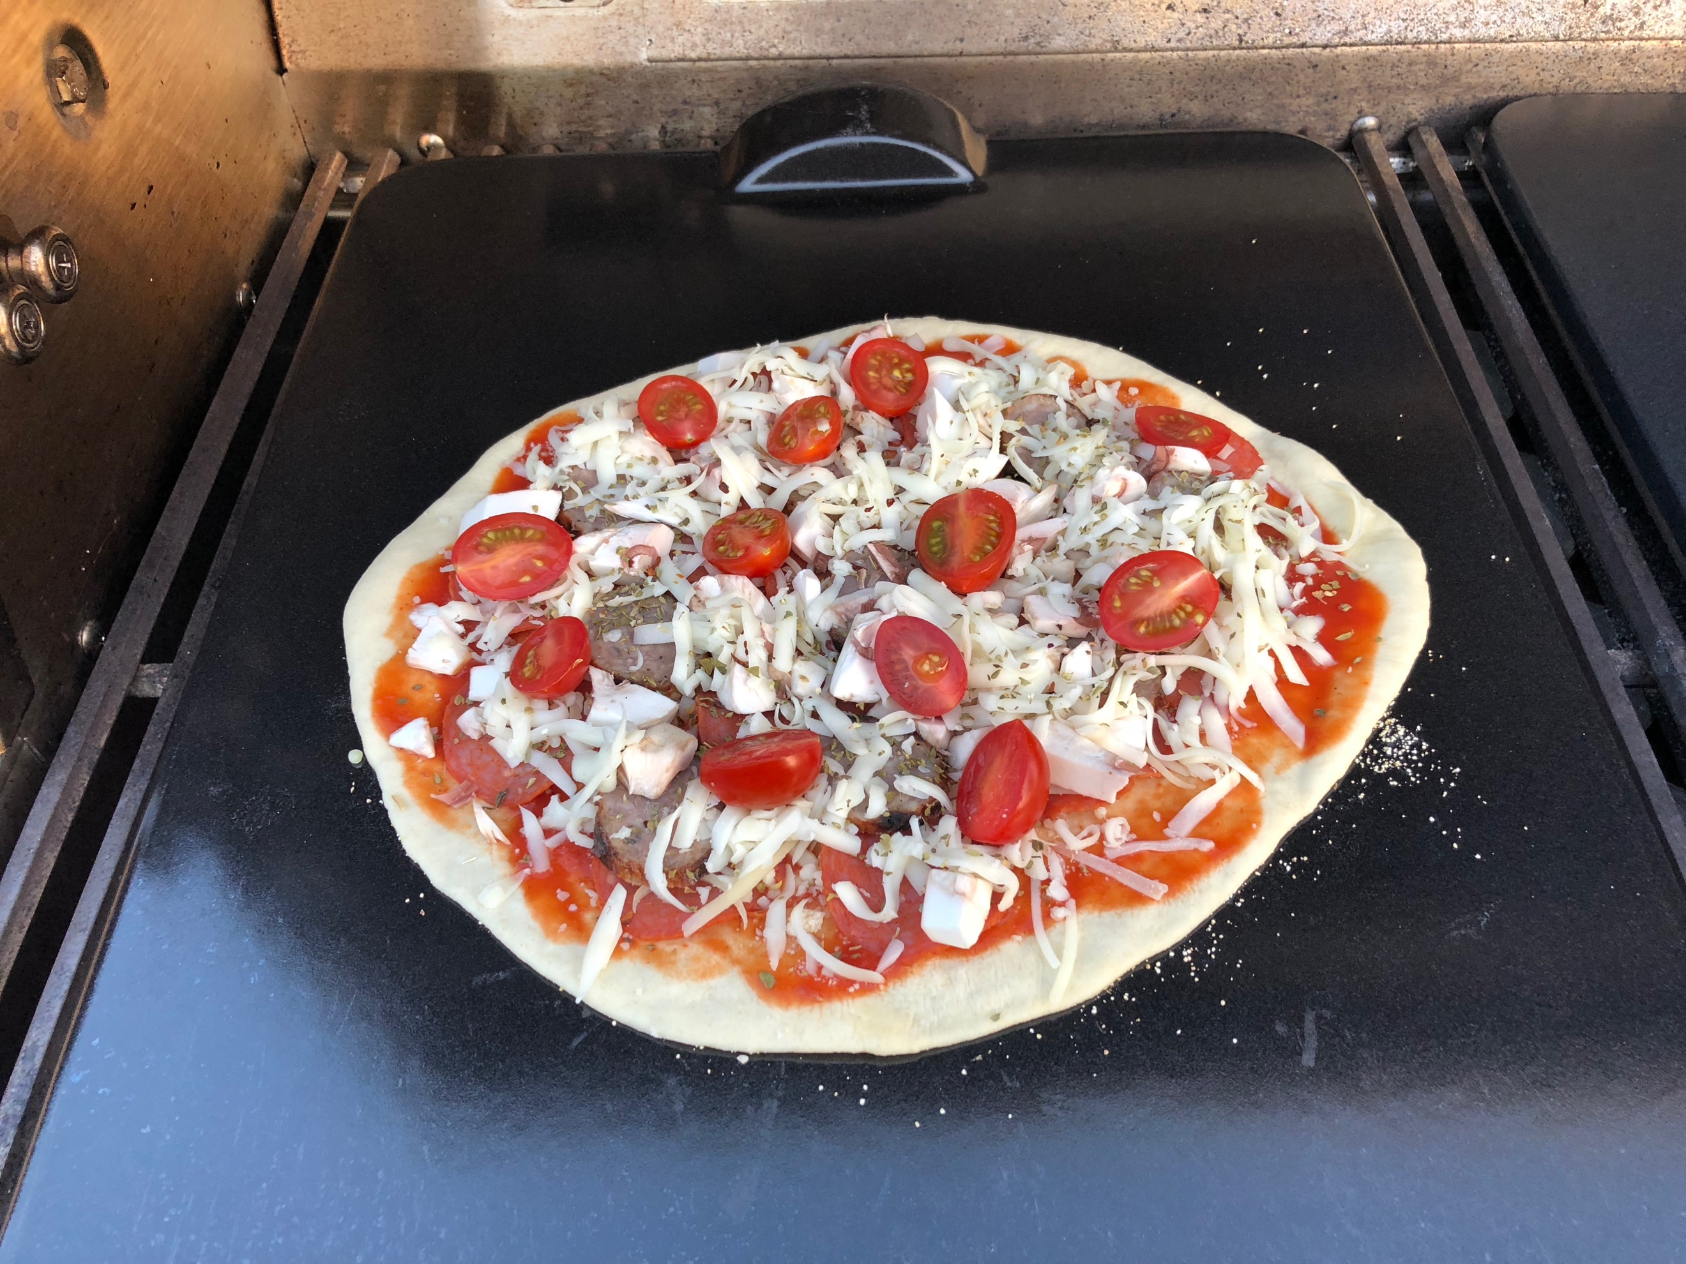

mangia! mangia!

Basic Pizza Dough

3 ½ cups Bread Flour
1 tsp sugar
2 tsp kosher salt
1 package instant dry yeast
1 ½ cups warm water, 110 degrees F
3 tbs olive oil, divided

Directions:
- Combine flour, sugar, salt and yeast in the bowl of a stand mixer and combine using the dough hook. While the mixer is running, slowly add the water and 2 tbs of the oil until if forms into a solid ball. If the dough is too wet, add 1 tbs of flour at at time. If the dough is too dry, add 1 tbs of water at a time. Turnout onto a floured surface and lightly kneed the dough into a ball.
- Grease a bowl with the remaining 1 tbs of oil, place the dough in the bowl and cover with plastic wrap. Place in a warm area for about an hour.
- Turn the dough out onto a floured surface and divide into 4 equal pieces. Cover with plastic wrap and let rest 15 minutes.
- Roll out each piece into a 10-12 inch pizza crust.

Favorite Traditional Pizza Toppings

- Pomi Pizza Sauce
- Quattro Formaggio (Trader Joe’s)
- Mozzarella cheese
- Fresh mozzarella
- Grated parmesan cheese
- Pepperoni/
- Mushrooms
- Sausage
- Artichokes
- Olives
- Bell pepper
- Onions
- Dried oregano
- Red pepper flakes

